**MLX90614 Housing Build Instructions**

**Tool Information**

* Super glue
* Soldering Iron
* Screwdriver (Probably Phillips - dependent on the screws present on T-conduit)

**Assembly Instructions**

1. Super glue the faucet repair kit together, and then glue the washer to the smooth rim of the coupling as shown below.

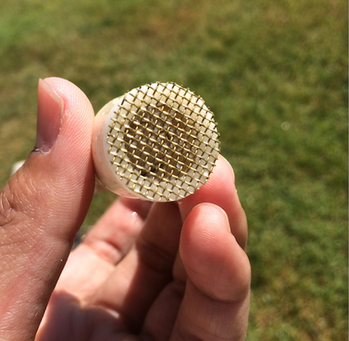

1. After the glue is dry, insert the assembly into the ½ inch PVC T-coupling so the screen is on the inside of the coupling. Push on the assembly to ensure a tight fit.

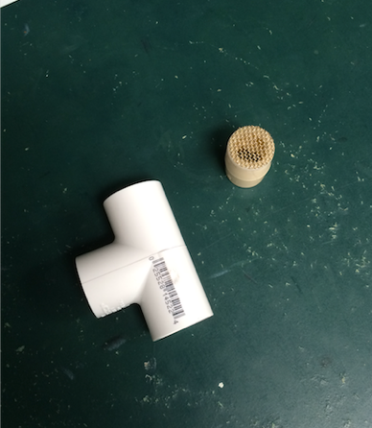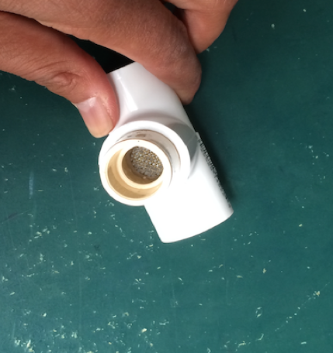

1. Unscrew the lid of the ½ inch PVC T-conduit and super glue the zinc-plated fender washer such that the washer hole is centered over the T-conduit hole. See picture on next page.

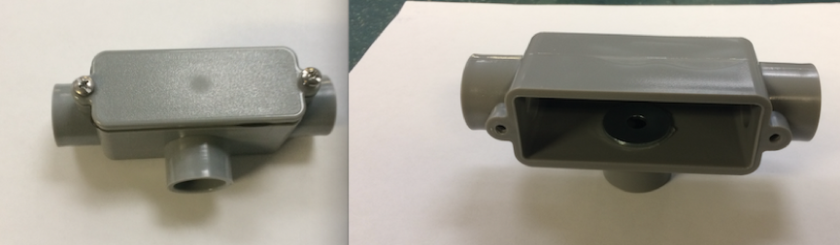

1. Insert the ½ inch PVC 90° elbow into the T-conduit. The flared end of the 90° elbow should be pointing towards the ground, as should the hole in the T-conduit with the washer.

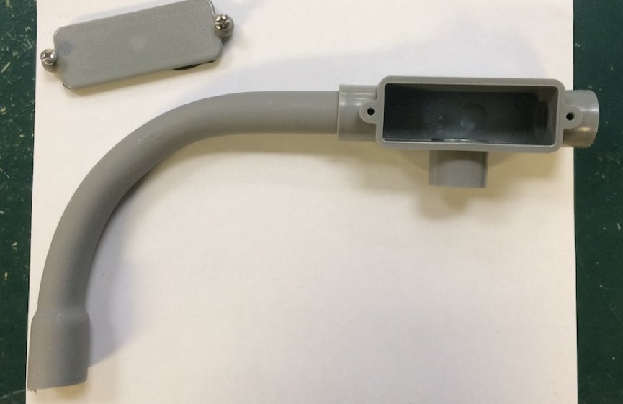

1. Insert the assembly from step 2 to the open end of T-conduit opposite of the 90° elbow.

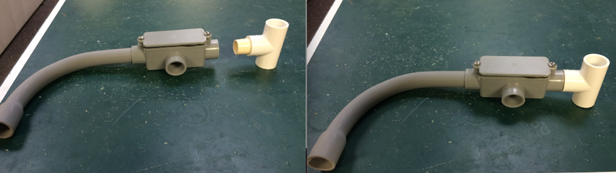

1. Solder the IR sensor to the multi-strand wire and super glue the rubber washer to the PCB. The rubber washer should fit around the metal can of the sensor. Ensure the lens is protruding past the plane of the washer to avoid reading interference. Avoid getting super glue on the lens. See image on the next page.

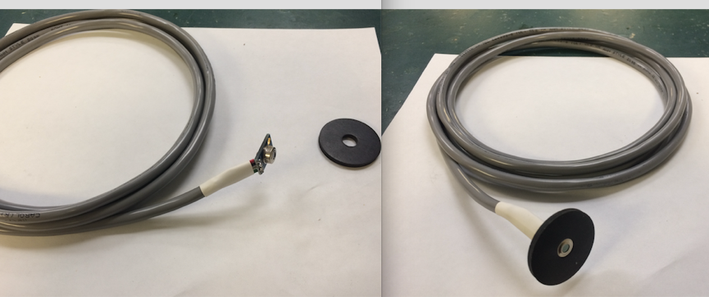

1. Insert the free end of the wire through the opening at the bottom of the T-conduit and through the 90° PVC elbow.

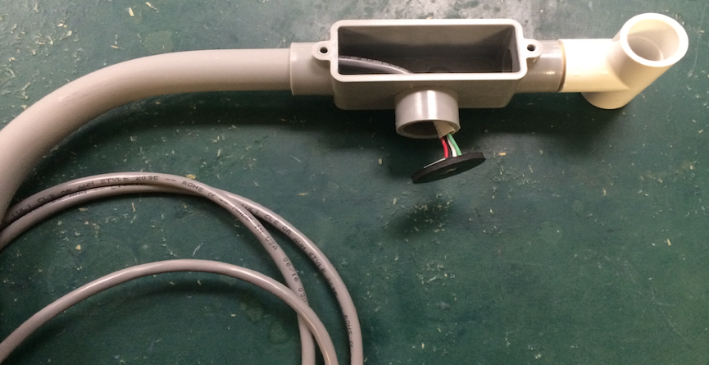

1. Glue the rubber washer to the T-conduit and zip tie the wire to the 90° elbow for strain relief.

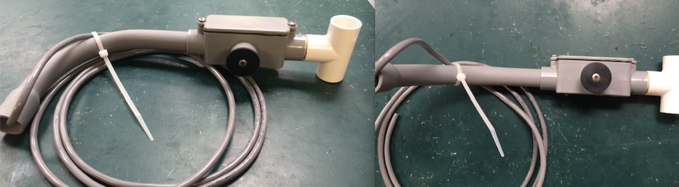

**Usage Information**

Using a hose clamp, attach the MLX90614 housing to the LEMS t-post, or to whatever is available. Visually ensure that nothing but ground is in the field of view of MLX90614 sensor.